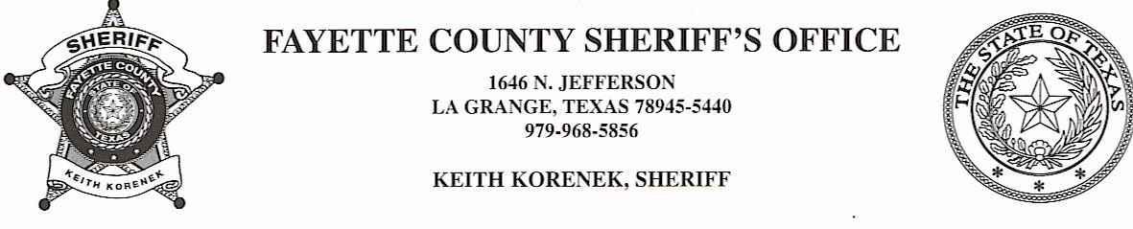

NOTICE OF ESTRAY AND IMPOUNDMENT

Two Heifers with ear tags in left ear #2 and #51 along with 2 young red bull steers wondered their way onto 6443 Withers Road, in the Ledbetter, Fayette County, Texas area. Pursuant to the stock laws of the State of Texas, Chapter Four, Title 121, Revised Civil Statutes of Texas 1925, said estrays have been impounded. Impoundment is at the Flatonia Livestock Commission.

A diligent search has been conducted to locate the owner, to no avail. Notice is hereby given that, if the ownership of estrays is not determined by the 19th day of December, 2023, said estrays will be sold at public auction/Sheriff’s sale at Flatonia Livestock Commission in Flatonia, Texas.

To claim affidavit of ownership, please contact Deputy Joe Gonzales with the Fayette County Sheriff’s Office at 979-968-5856.

